**10-17 notes**

APIs

Goals:

By the end of this lesson, you will be able to:

* Make get requests with the Request library.
* Convert JSON into a Python dictionary.
* Read and apply API documentation.
* Sign up for and use an API key.

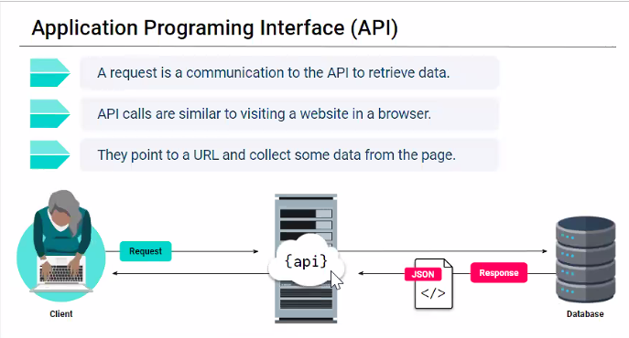

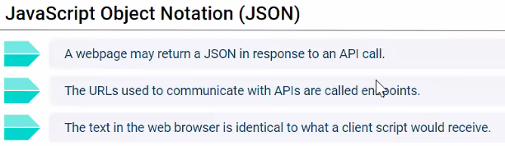

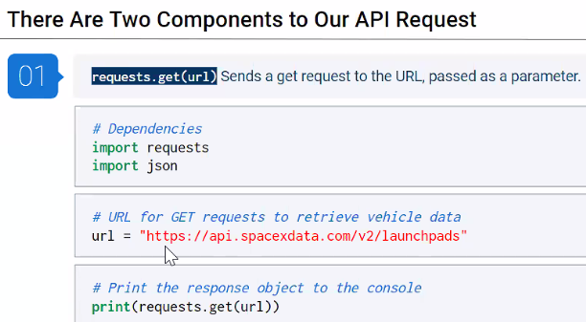

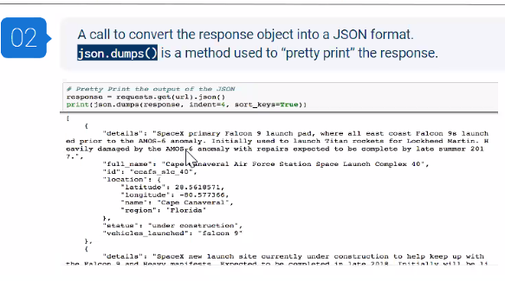

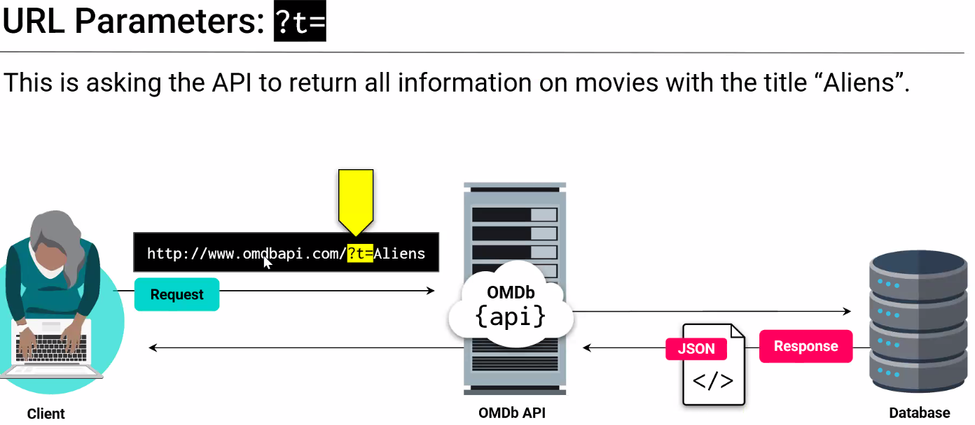

^ ?t= is the call/request. In this case, it’s title.

This website requires a key.

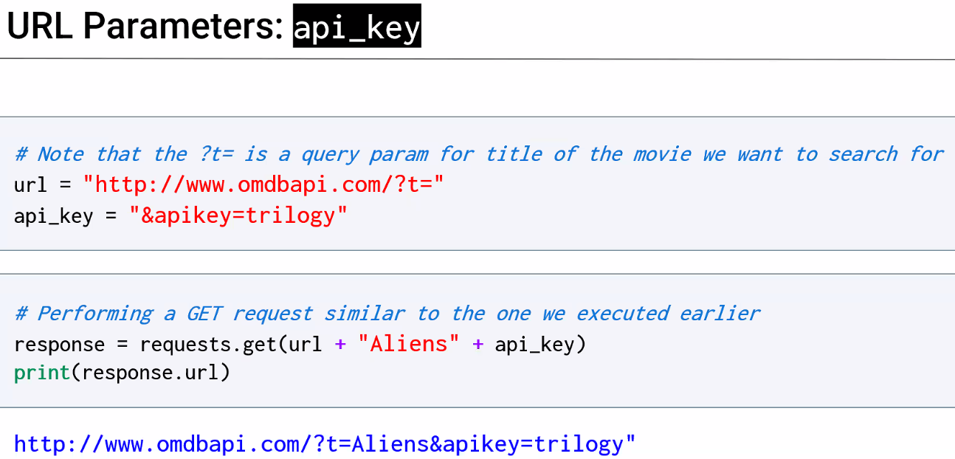

NEVER PUT YOUR KEY IN YOUR CODE. Put it in a file called config.py and call it.

**OMDB requests solution:**

